# Food Service Website

### A MINI PROJECT REPORT

#### Submitted by

#### Group: G12

**Aniket Sharma,2410990920,**

**Aarnav Singla, 2410990889,**

**Anshvesh Baghla, 2410990932,**

#### in partial fulfillment for the award of the

#### degree of

## BACHELOR OF ENGINEERING

***in***

CSE



**CHITKARA UNIVERSITY**

**CHANDIGARH-PATIALA NATIONAL HIGHWAY**

**RAJPURA (PATIALA) PUNJAB-140401 (INDIA)**

##### November,2024

###### TABLE OF CONTENTS

| **Sr.no** | **Section** | **Page no** |
| --- | --- | --- |
| **1.** | Introduction | 1 |
| **2.** | Technical Details | 2 |
| 4. | Key Features | 3 |
| **5.** | Projects Highlights | 4-7 |
| **6.** | Bonus Feature | 8 |
| **7.** | Conclusion | 9 |

###### 

###### 1

**Introduction: -**

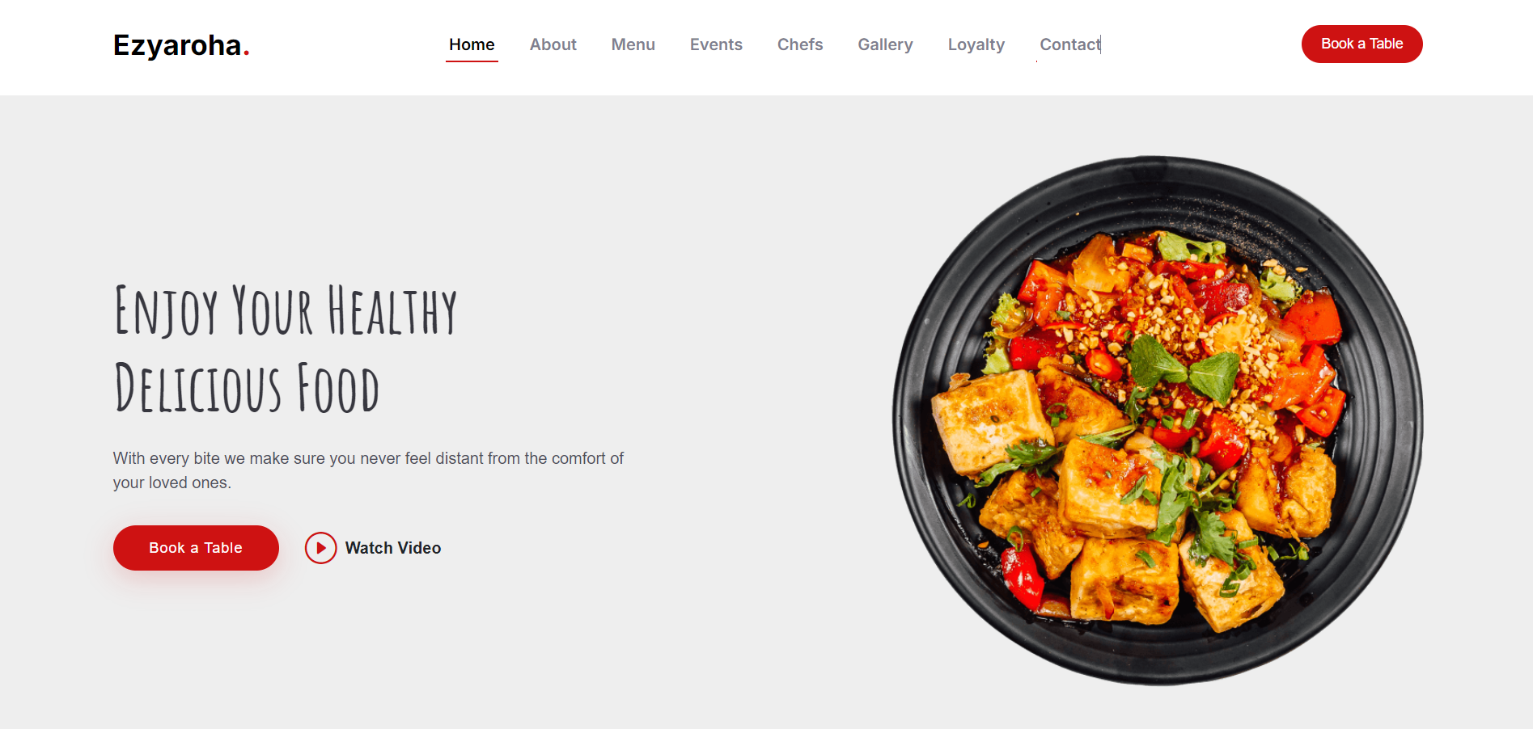

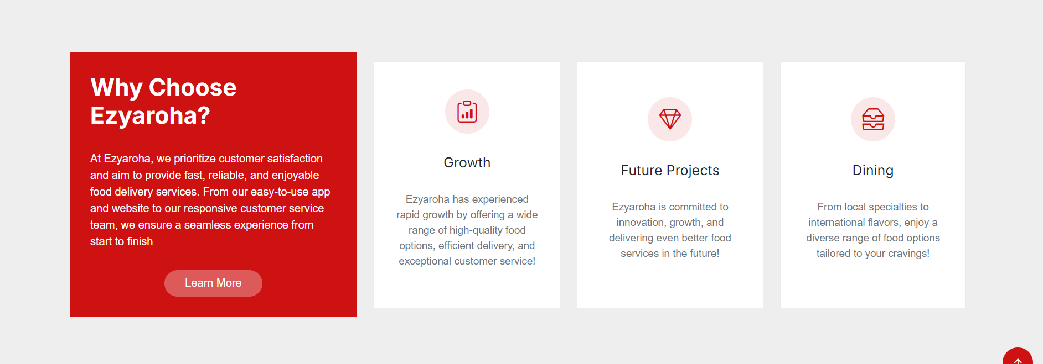

2

Technical Details: -



 



3

Key Features: -

* Virtual Table Reservation
* Seasonal Specials and Limited-Time Offers
* Loyalty rewards and point systems
* Chef’s Specials with Story Background
* “Mood-Based” Food Finder

4

Project Highlights

New Interface: -

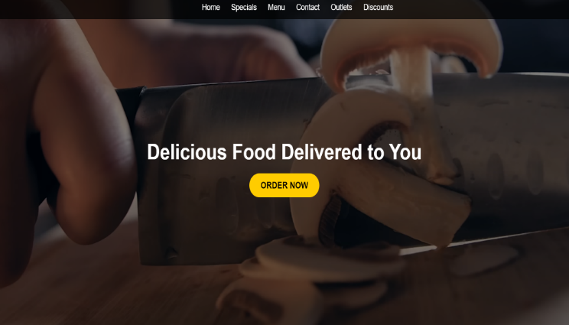 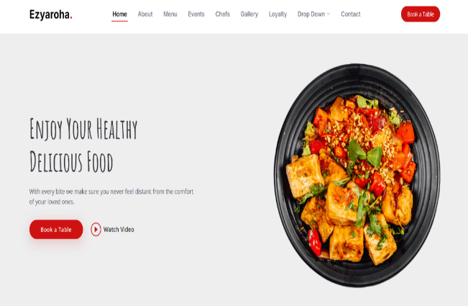



5

Testimonial: -

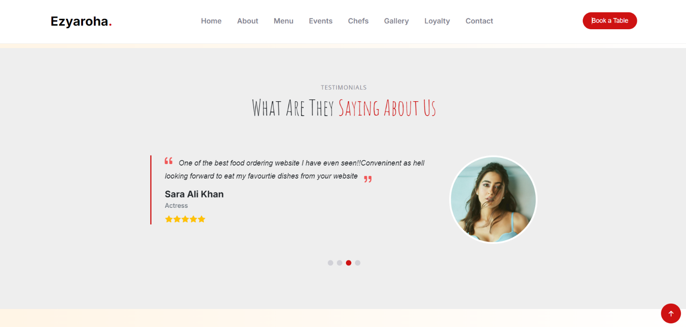

Code: -

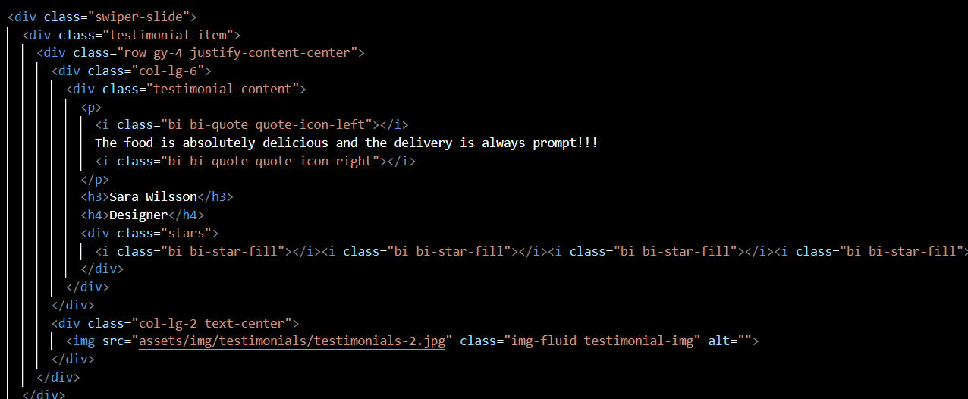

6

Virtual Table Reservation: -

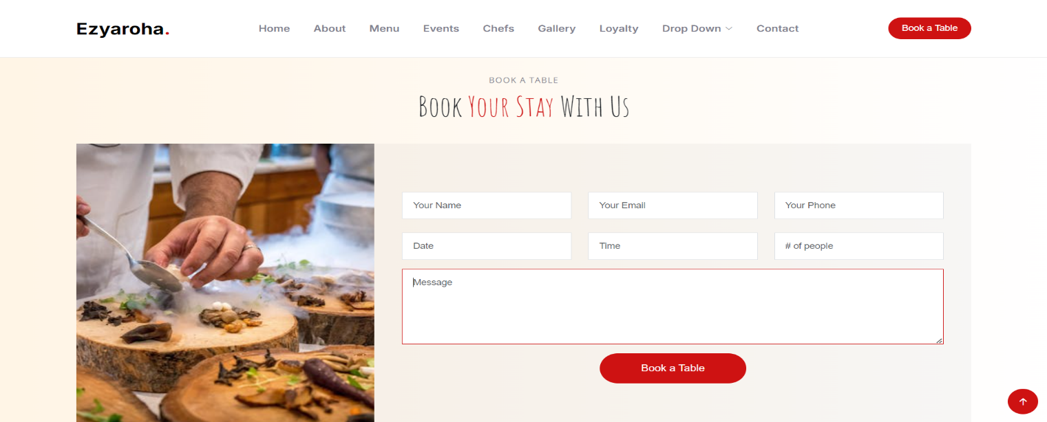

Code: -

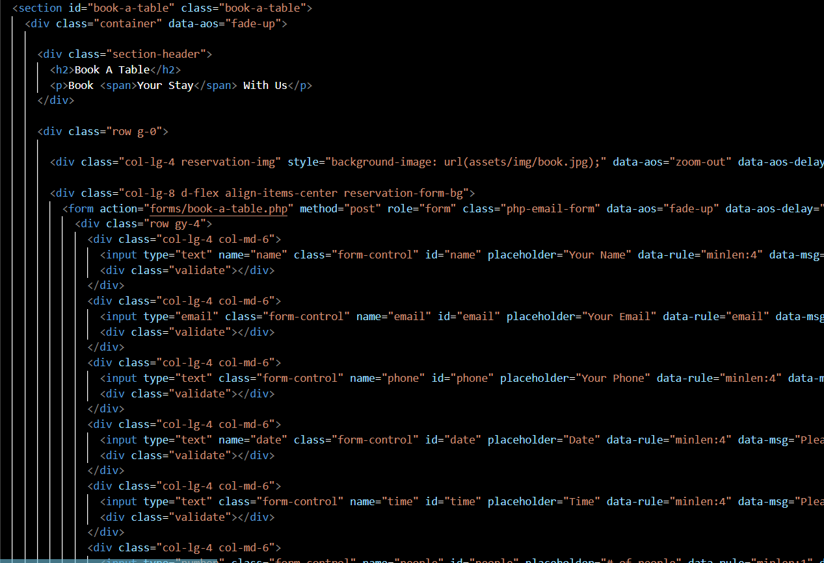

7

From Sunrise to Sunset: A Feast for Every Moment: -

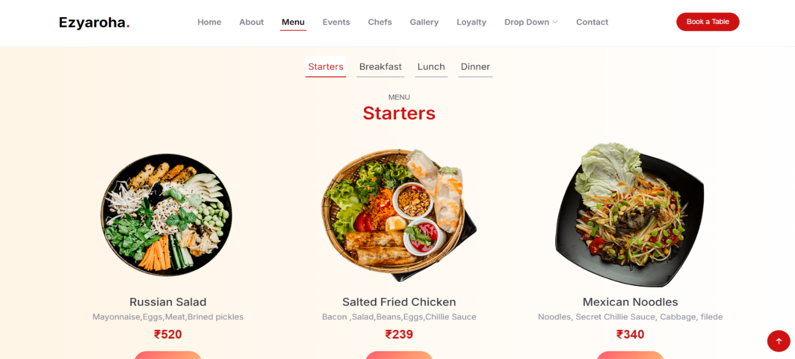

Code: -

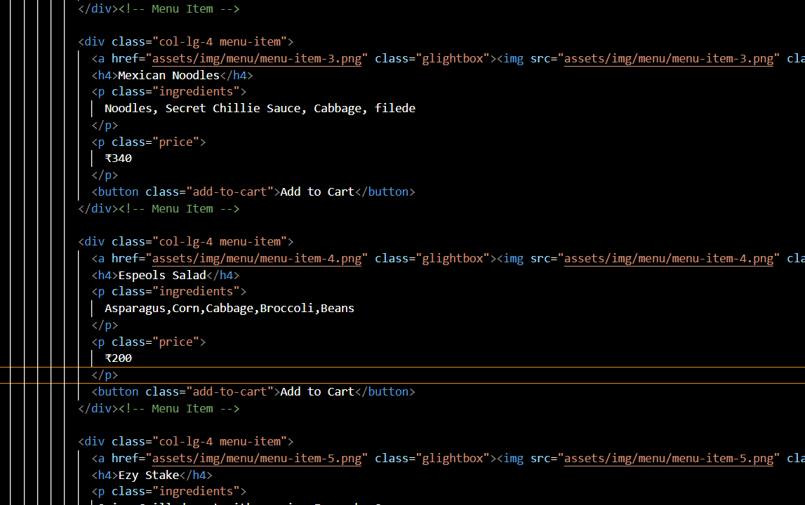

8

Bonus Feature: -

Special Events: -

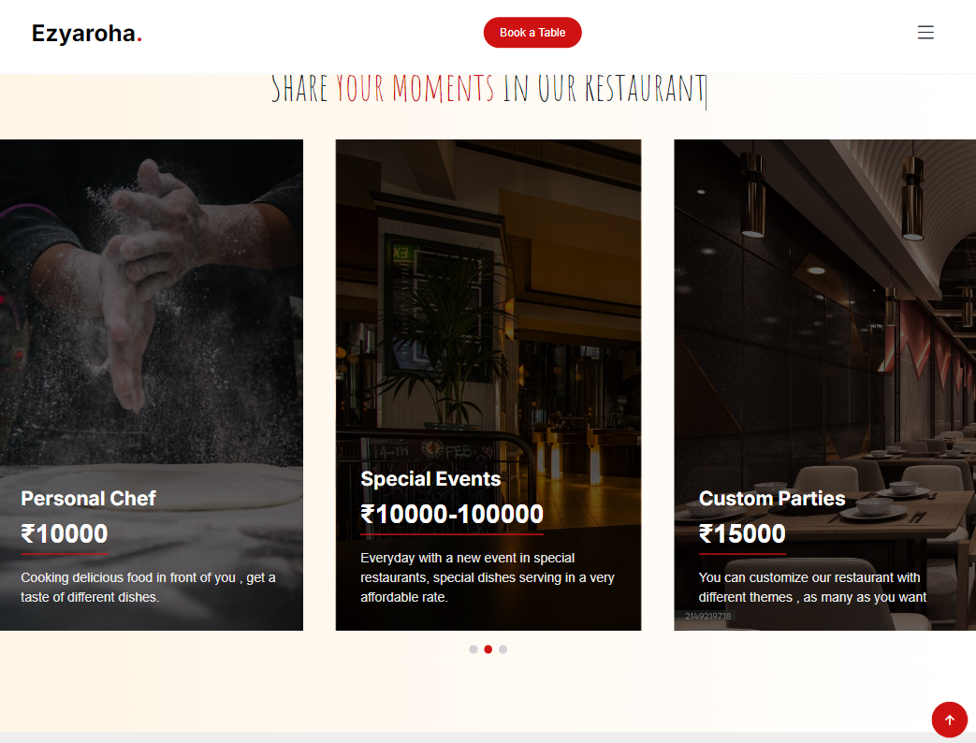

Code: -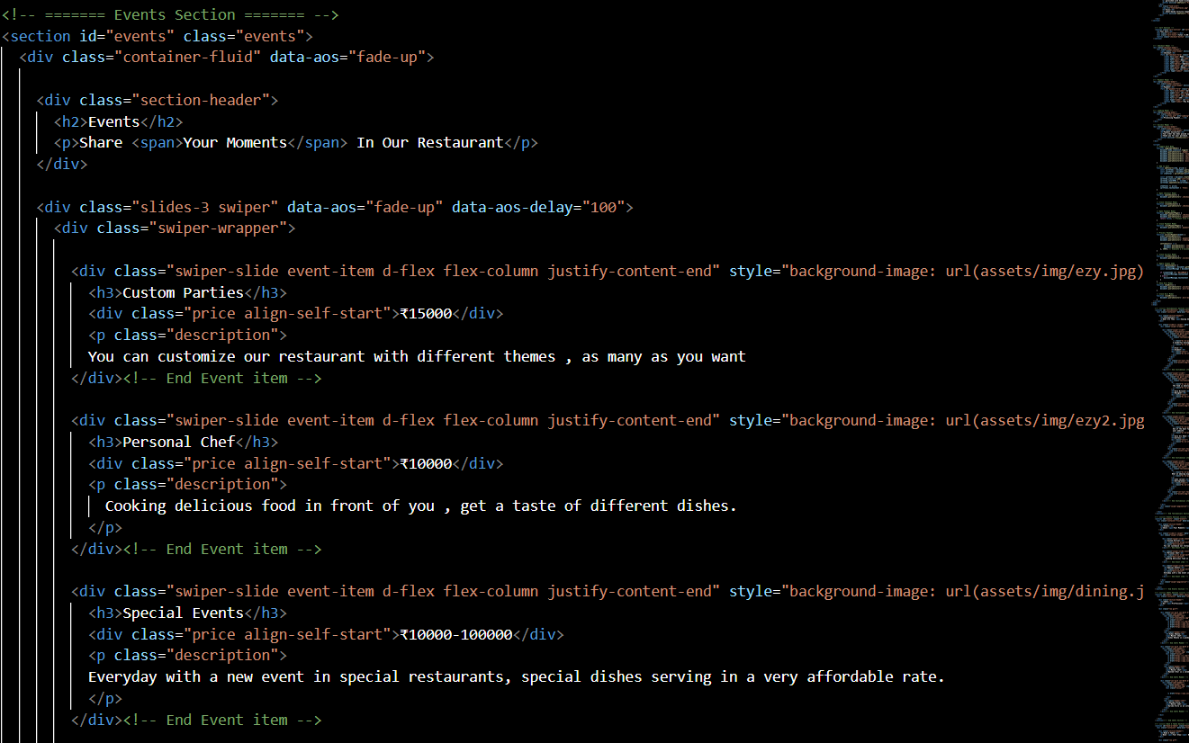

9

Conclusion: -

We developed a food delivery website which solves various and basic aspects of problems which other companies don’t do. Our website offers a very user-friendly interface, engaging user experience, diversity of food to try etc. “

We learned the real use of html, CSS and JavaScript after making a project in a detailed way, how to make users engage, and the challenges and errors.